Personal Consumption Expenditures
Price Index
Healthcare

Table of Contents

General Note 3
SECTION 1: Organization of Healthcare in the PCE and Published PCEPI Tables 4
(1) General Categorization of Healthcare Goods and Services 5
(2) Categorization of Aggregated Healthcare Goods and Services 6
SECTION 2: Constructing the PCEPI for Healthcare Services: Physician Services in 2014 7
Step 1: Find the growth in prices from the previous period to the current period 7
Step 1 Example 8
Step 2: Find the current period’s PCEPI value given the previous period’s value 10
Step 2 Example 10
SECTION 3: Considerations for Construction 12
Consideration 1: Determine total expenditure in each period 12
Consideration 1 Example 14
Consideration 2: Inflate and deflate by the corresponding price index 15
Producer Price Index (PPI) 16
Consumer Price Index (CPI) 16
SECTION 4: A Quicker Approach to Estimating the PCEPI Value for Subcategories 19
APPENDIX 21
Haver Codes 21
Personal Consumption Expenditures (PCE) 22
Producer Price Index (PPI) Adjustment Indexes 23
Consumer Price Index (CPI) Adjustment Indexes 23
Organization of Healthcare in the PCE and Published Nominal Expenditure Tables 24

General Note
The Personal Consumption Expenditures (PCE) is released monthly by the Bureau of Economic Analysis (BEA) as part of its Personal Income and Outlays Report (PIO) under the National Income and Product Accounts (NIPAs). The PCE measures consumer spending on goods and services by persons resident in the United States or by those buying on their behalf. In other words, the PCE captures consumption by “persons”—all households and Nonprofit Institutions Serving Households (NPISHs)—and the government.
The PCE Price Index (PCEPI) extends upon the PCE as a measure of the change in prices of goods and services purchased by the classes of consumers detailed above. The PCEPI captures inflation (or deflation) across these goods and services and also reflects changes in consumer spending behavior. The PCEPI is constructed using the Fisher Price Index formula, which is chained and superlative. Being chained means it links price changes from adjacent periods, whereas being superlative means it averages weights from both periods for greater accuracy, reducing substitution bias. The index’s weights (i.e. relative expenditures) are updated monthly and are largely based on business surveys’ data on revenue.
The PCEPI, and the PCE generally, release monthly, quarterly, and annual estimates. These are subject to revisions for several years past the initial publications. Major revisions can be due to the comprehensive update which occurs about every five years (when the reference year is changed) or due to updated data during annual benchmarking.

SECTION 1: Published PCEPI Tables and Organization of Healthcare in the PCE
The BEA has two systems, as determined by the NIPAs framework, by which it categorizes the goods and services relevant to healthcare in the PCE. Both are listed in this section along with relevant tables in which PCEPI values are published. (1) The first system has an aggregated category for healthcare services but does not have an aggregated category of the such for goods. Instead, healthcare goods are dispersed between durable and nondurable goods. (2) The second system details an overall aggregated health category. This system has an aggregated category for healthcare goods, but does not have an aggregated category of the such for services. The aggregated categories for goods and services, within their respective systems, are in blue.
The BEA publishes a series of PCE tables, each of which presents data by different categorization systems, different levels of aggregation, or both. The two categorization systems are rarely published together in the same table, especially not with all components of both systems published. For example, in one table, the first categorization system could be fully published along with only the fully aggregate health category of the second categorization.
The two systems’ categorizations are listed in this section according to the numbering established in the first paragraph. All goods and services, except those found in gray, can be found across the main tables published for the PCE. Any good or service in gray can only be found in the PCE’s Underlying Detail Tables. These tables include highly disaggregated estimates, presenting information for components such as the ones in gray. Please note the BEA does not recommend relying on the highly disaggregated values in the Underlying Detail Tables.
Published PCE data tables can be accessed through the BEA’s Interactive Data Application. This link leads to the home page for accessing these tables with values at the national level. Follow the orange button titled “Interactive Data Tables” >> “SECTION 2 – PERSONAL INCOME AND OUTLAYS” to find the main published tables for PCE. For the Underlying Detail Tables, rather than the orange button, click on “Underlying Detail Tables” in the bullet points below. Then find the same section header. The relevant PCEPI tables’ numbers and titles include:
2.3.4: Price Indexes for Personal Consumption Expenditures by Major Type of Product (Q) (A)
2.3.4U: Price Indexes for Personal Consumption Expenditures by Major Type of Product and by Major Function (M) (Q) (A)
2.4.4: Price Indexes for Personal Consumption Expenditures by Type of Product (Q) (A)
2.4.4U: Price Indexes for Personal Consumption Expenditures by Type of Product (M) (Q) (A)
2.5.4: Price Indexes for Personal Consumption Expenditures by Function
2.8.4: Price Indexes for Personal Consumption Expenditures by Major Type of Product, Monthly

Systems for Organizing Healthcare Goods and Services in the PCE
Below are detailed listings of the two main healthcare categorization systems mentioned at the beginning of the section. In brackets, following each category or component, is a list of PCEPI tables where corresponding price index values can be found.
KEY
italicized | Healthcare service relevant to this guide
(U) | Main table and underlying table
U | Underlying table only

(1) General Categorization of Healthcare Goods and Services
- Goods [2.3.4(U), 2.4.4(U), 2.8.4]
  - Durable goods [2.3.4(U), 2.4.4(U), 2.8.4]
    - Other durable goods [2.3.4(U), 2.4.4(U), 2.8.4]
      - Therapeutic appliances and equipment [2.4.4(U), 2.5.4]
        - Therapeutic medical equipment [2.4.4U]
        - Corrective eyeglasses and contact lenses [2.4.4U]
  - Nondurable goods [2.3.4(U), 2.4.4(U), 2.8.4]
    - Other nondurable goods [2.3.4(U), 2.4.4(U), 2.8.4]
      - Pharmaceutical and other medical products [2.4.4(U), 2.5.4]
        - Pharmaceutical products [2.4.4U, 2.5.4]
          - Prescription drugs [2.4.4U]
          - Nonprescription drugs [2.4.4U]
        - Other medical projects [2.4.4U, 2.5.4]
- Services [2.3.4(U), 2.4.4(U), 2.8.4]
  - Health care [2.3.4(U), 2.4.4(U), 2.8.4]
    - Outpatient Services [2.4.4(U), 2.5.4]
      - Physician services [2.4.4(U), 2.5.4]
      - Dental services [2.4.4(U), 2.5.4]
      - Paramedical services [2.4.4(U), 2.5.4]
        - Home health care [2.4.4U, 2.5.4]
        - Medical laboratories [2.4.4U, 2.5.4]
        - Other professional medical services [2.4.4U, 2.5.4]
          - Specialty outpatient care facilities and health and allied services [2.4.4U]
          - All other professional medical services [2.4.4U]
    - Hospital and nursing home services [2.4.4(U), 2.5.4]
      - Hospitals [2.4.4(U), 2.5.4]
        - Nonprofit hospitals’ services to households [2.4.4U]
        - Proprietary hospitals [2.4.4U]
        - Government hospitals [2.4.4U]
      - Nursing homes [2.4.4(U), 2.5.4]
        - Nonprofit nursing homes’ services to households [2.4.4U]
        - Proprietary and government nursing homes [2.4.4U]
  - Financial services and insurance [2.3.4(U), 2.4.4(U), 2.5.4, 2.8.4]
    - Insurance [2.4.4(U), 2.5.4]
      - Net health insurance [2.4.4(U), 2.5.4]
        - Medical care and hospitalization [2.4.4U, 2.5.4]
        - Income loss [2.4.4U, 2.5.4]
        - Workers’ compensation [2.4.4U, 2.5.4]

(2) Categorization of Aggregated Healthcare Goods and Services
- Health [2.3.4U, 2.5.4]
  - Medical products, appliances, and equipment [2.5.4]
    - Pharmaceutical and other medical products [2.4.4(U), 2.5.4]
      - Pharmaceutical products [2.4.4U, 2.5.4]
      - Other medical products [2.4.4U, 2.5.4]
    - Therapeutic appliances and equipment [2.5.4]
  - Outpatient services [2.4.4U, 2.5.4]
    - Physician services [2.4.4(U), 2.5.4]
    - Dental services [2.4.4(U), 2.5.4]
    - Paramedical services [2.4.4(U), 2.5.4]
      - Home health care [2.4.4U, 2.5.4]
      - Medical laboratories [2.4.4U, 2.5.4]
      - Other professional medical services [2.4.4U, 2.5.4]
  - Hospital and nursing home services [2.4.4(U), 2.5.4]
    - Hospitals [2.4.4(U), 2.5.4]
    - Nursing home [2.4.4(U), 2.5.4]

SECTION 2: Constructing the PCEPI for Healthcare Services: Physician Services in 2014
To construct the PCEPI, the value for each of the four components of the Fisher Price Index formula must be determined—for the component/aggregation level in question.
The Fisher Price Index is the geometric mean of the Laspeyres Price Index and the Paasche Price Index. Both price indexes keep quantity (i.e. the quantity basket) fixed and find the change in the total expenditure on this quantity basket when shifting in terms of one period’s prices to the other period’s prices. The Laspeyres Price Index holds constant the quantity basket from the previous period, and the Paasche Price Index holds constant the quantity basket from the current period.
The PCEPI considers adjacent periods (months, quarters, or years). Being a geometric mean of the two price indexes, the Fisher Price Index accounts for the substitution effect of consumers’ changed spending behavior between the previous and the current period. In the PCEPI, the quantities of goods and services serve as weights for their corresponding prices.
The steps for calculating a PCEPI value are detailed below, supplemented with the procedure for constructing the PCEPI value for Physician Services in 2014.

Step 1: Find the growth in prices from the previous period to the current period.
$${\left(Fisher Price Index\right)}_{t}$$
$$= \sqrt{{\left(Laspeyres Price Index\right)}_{t}⋅{\left(Paasche Price Index\right)}_{t}}$$
$$=\sqrt{\left(\frac{\sum{p_{t}q_{t-1}}}{\sum{p_{t-1}q_{t-1}}}\right)⋅\left(\frac{\sum{p_{t}q_{t}}}{\sum{p_{t-1}q_{t}}}\right)}$$
$= g_{t}$,
where t is the current period and t-1 is the previous period;
p is price, q is quantity, and g is the growth rate.
Explained further in Consideration 1 and 2: The data available through the PCE represent the product of price and quantity, with no differentiation between price and quantity. Therefore, to find the value of a quantity basket in a different period than its own, a corresponding price index must be used to deflate or inflate the nominal value of the quantity basket.
Here is an explanation of what each component of the Fisher Price Index represents and, if applicable, how to find it using inflation or deflation. Going in a clockwise direction of products beginning with the bottom left corner:

$p_{t-1}q_{t-1}$ is the total expenditure as of the previous period. In other words, it is the value of the total goods and services purchased in the previous period in terms of the previous period’s prices. This is a data point published in the BEA’s PCE tables on nominal consumption expenditures.
$p_{t}q_{t-1}$ is the total expenditure of the previous period in terms of the current period’s prices. It can be found by inflating $p_{t-1}q_{t-1}$ by the appropriate corresponding price index (i.e. multiplying $p_{t-1}q_{t-1}$ by $\frac{p_{t}}{p_{t-1}}$) to find the value of the total goods and services purchased in the previous period in terms of current period prices. $\frac{p_{t}}{p_{t-1}}$ is the quotient of two data points ($p_{t}$ and$p_{t-1}$) published in either PPI or CPI tables.
$p_{t}q_{t}$ is total expenditure as of the current period. In other words, it is the value of the total goods and services purchased in the current period in terms of the current period’s prices. This is a data point in the BEA’s PCE tables on nominal consumption expenditures1.
$p_{t-1}q_{t}$ is the total expenditure of the current period in terms of the previous period’s prices. It can be found by deflating $p_{t}q_{t}$ by the appropriate corresponding price index2 (i.e. dividing $p_{t}q_{t}$ by $\frac{p_{t}}{p_{t-1}}$ ), so it is in terms of the previous period’s prices. $\frac{p_{t}}{p_{t-1}}$ is the same quotient as before, found using data points published in either PPI or CPI tables.

Step 1 Example: Finding the growth rate for Physician Services from 2013 to 2014.
This example follows the first step to constructing the PCEPI value for Physician Services at the annual level in 2014.
$${\left(Fisher Price Index\right)}_{t}$$
$$= \sqrt{{\left(Laspeyres Price Index\right)}_{t}⋅{\left(Paasche Price Index\right)}_{t}}$$
$$=\sqrt{\left(\frac{\sum{p_{t}q_{t-1}}}{\sum{p_{t-1}q_{t-1}}}\right)⋅\left(\frac{\sum{p_{t}q_{t}}}{\sum{p_{t-1}q_{t}}}\right)}$$
$= g_{t}$,
where t = 2014, t-1 = 2013.
To find the values for the four elements of the Fisher Price Index formula, two data values for each period are required: the PCE nominal consumption expenditure value and the PPI price index value for Offices of Physicians2. For this example, the published values for each period are as follows:
Period | Nominal Expenditure (PCE)  (in millions of dollars) | Price Index Value for Offices of Physicians (PPI)
2013 | 444846 | 133.433
2014 | 466193 | 134.175
Haver Codes | CSMPY@USNA | R6211@PPIR
Table Linked  in Haver | Table 2.4.5  (BEA PCE) | Table 10  (BLS PPI)

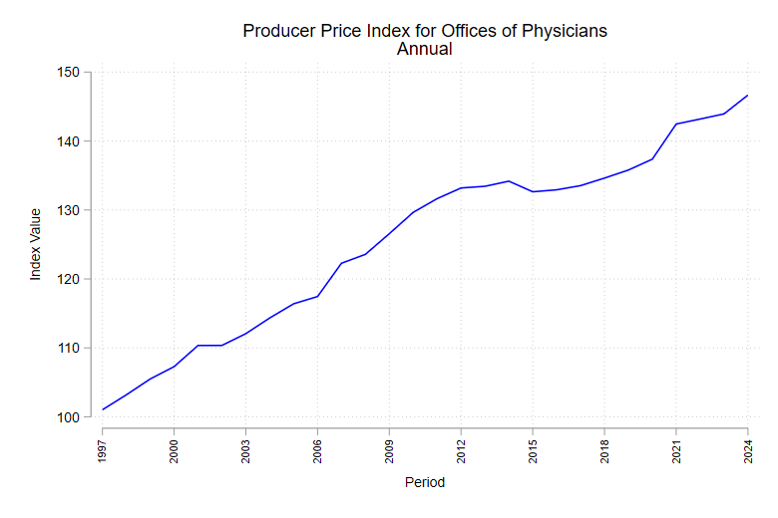
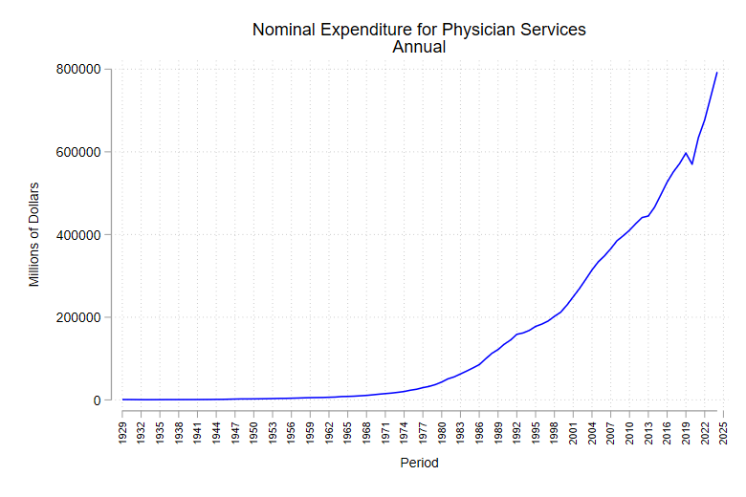
The following graphs show the trend in nominal expenditure in a year on Physician Services and the PPI value for Offices of Physicians from 1997 to 2025. This year range represents the time frame over which there is an estimate for both publications.
$p_{2013}q_{2013}$ is total expenditure on physician services as of the previous period. This is the value of nominal expenditure on physician services as of 2013 in the published PCE tables.
$$p_{2013}q_{2013} = 444846$$
$p_{2014}q_{2013}$ is found by inflating $p_{2013}q_{2013}$, estimating the value of total expenditure on physician services in 2013 in terms of 2014 prices. To inflate, multiply $p_{2013}q_{2013}$ by $\frac{p_{2014}}{p_{2013}}$, where $p_{2014}$ is the PPI Offices of Physicians price index value for 2014, and $p_{2013}$ the same for 2013.
$$p_{2014}q_{2013} = 444846 ∙\left(\frac{134.175}{133.433}\right)$$
$$= 447318.6$$
$p_{2014}q_{2014}$ is the total expenditure on physician services as of the current period. This is the value of nominal expenditure on physician services as of 2014 in the published PCE tables.
$$p_{2014}q_{2014} = 466193$$

$p_{2013}q_{2014}$ is found by deflating $p_{2014}q_{2014}$, estimating the value of total expenditure on physician services in 2014 in terms of 2013 prices. To deflate, divide $p_{2014}q_{2014}$ by $\frac{p_{2014}}{p_{2013}}$.
$$p_{2013}q_{2014}= 466193÷ \left(\frac{134.175}{133.433}\right)$$
$$= 463616.1$$
Now that all four elements’ values have been found, apply the Fisher Price Index formula:
$$\sqrt{\left(\frac{\sum{447318.6}}{\sum{ 444846}}\right)⋅\left(\frac{\sum{466193}}{\sum{463616.1}}\right) }$$
$$= 1.005558 = g_{2014}$$
From 2013 to 2014, prices grew by a multiplicative factor of about 1.006.

Step 2: Find the current period’s PCEPI value given the previous period’s value.
An iterative method, which keeps the base period consistent, is used to determine the index value for the current time period:
$$v_{t}=v_{t-1}⋅g_{t}$$
$$v_{t-1}=v_{t-2}⋅g_{t-1},$$
where t-2 is the period before the previous period and v is the published PCEPI value.
Published PCEPI values can be found in the appropriate table as detailed in SECTION 1. The current base period for the PCEPI is 2017, so all published index values are relative to the annual base period of 2017 where $v_{2017}= 100$.

Step 2 Example: Find the PCEPI value for Physician Services in 2014 given the 2013 value.
Given
$$v_{t}=v_{t-1}⋅g_{t}$$
$$v_{t-1}=v_{t-2}⋅g_{t-1},$$
where t = 2014, t-1 = 2013.
$v_{2014}$ is the final PCEPI index value for physician services as of 2014. $v_{2013}$ is the published PCEPI value for 2013. Both values are found in any of the tables listed by Physician Services in the detailed organization structures in Section 1.
Given $v_{2013} = 99.924$,
$$v_{2014}=v_{2013}⋅g_{2014}$$
$$=99.924⋅1.005558$$
$$=100.4794$$
The PCEPI value for Physician Services in 2014 is about 100.48. This means the prices in 2014 are about 0.48% greater than prices in the base year of 2017.
The overall formula to find the PCEPI value for the current period:
$$v_{t} =\sqrt{\left(\frac{\sum{p_{t}q_{t-1}}}{\sum{p_{t-1}q_{t-1}}}\right)⋅\left(\frac{\sum{p_{t}q_{t}}}{\sum{p_{t-1}q_{t}}}\right)} ⋅ v_{t-1}$$
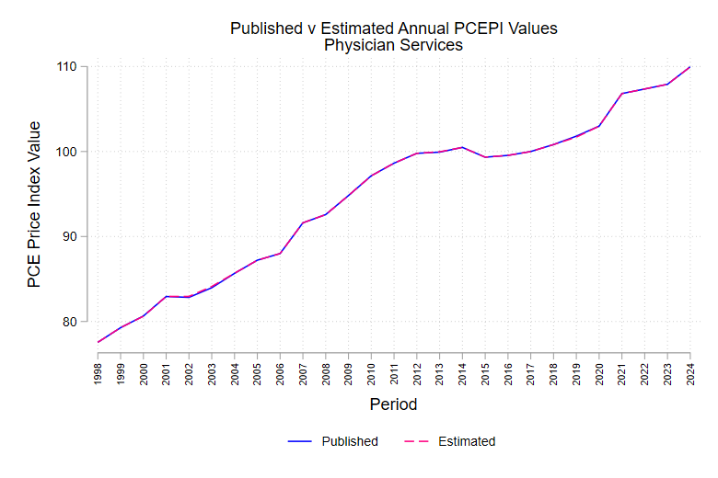

SECTION 3: Considerations for Construction
There are two considerations for finding the value of each of the four components of the Fisher Price Index formula. The first is to determine the total expenditure on goods and services in each of the adjacent periods (i.e. nominal expenditures) and at the aggregation level in question. The second is to determine the corresponding price indexes for the category or component in question. The corresponding price indexes are used to deflate and inflate the PCE’s total expenditure values as needed. This then results in the value of the two components not directly published by the BEA.
Consideration 1: Determine total expenditure in each period: $p_{t-1}q_{t-1}$ & $p_{t}q_{t}$
Although sometimes possible at the detailed component level, the highly aggregated NIPA components, such as healthcare services, do not have estimates of physical quantities available. This is because the source data for most components, especially for healthcare services, are measured in dollars, rather than units and prices. Source data presents the total expenditure at the nominal level, or in other words, the product of price and quantity as of the time period.
It is important to note that depending on the type of period—benchmark year, nonbenchmark year, or current quarterly estimate—different data sources and computational methods are used to establish the total expenditures in a period. For current quarterly estimates, PCE estimates are prepared using indicator series. Table 1 details all sources of data and indicator series that are used to establish the total expenditure for each component of healthcare services.
The total expenditure for healthcare services is the aggregation of the equivalent for all its components, which can be aggregations themselves. The BEA uses the sources in Table 1 to develop the published PCE values for total expenditure in a given period.

Table 1: Data Sources for Nominal Expenditure of Components of Health Care Services
 | Data Source
Component | ADA | CES | CMS | COG | EC | GF | SAS | QSS
Outpatient Services
Physician services |  |  |  |  | X |  | X | X
Dental services | X |  |  |  | X |  | X | X
Paramedical services |  | X |  |  | X |  | X | X
Hospital and
Nursing Home Services
Hospitals |  | X |  | X | X | X | X | X
Nursing homes |  | X | X |  | X |  | X | X

Abbreviation | Data Source | Description
ADA | American Dental Association | For the second of three and advance estimates for dental services, the patient volume data is used.  Patient volume data used for the second and advance quarterly estimates for dental services.
CES | Current Employment Statistics,  Bureau of Labor Statistics | The program provides industry estimates of nonfarm employment, hours, and earnings of workers on payroll at the national, state, and metropolitan level. Surveys approximately 121,000 businesses and govt agencies, representing about 631,000 individual worksites. Estimates are published monthly and are NAICS-based, meaning the estimates are presented organized according to the NAICS categories.  Employment, hours, and earnings data are used.  Employment, hours, and earnings data used for advance quarterly estimates for all three components and also the nonbenchmark year estimates for government hospitals.
CMS | Centers for Medicare and Medicaid Services | Nursing home occupancy data are used.
COG | Census of Governments,  Census Bureau | Occurs every five years, in years ending in 2 or 7. Identifies scope of American government at federal, state, and local government. Provides benchmark figures of public finance and public employment; classifies local government organizations and activities; and measures government fiscal relationships. Collects data from all state and local government, which includes counties, cities, townships, special districts, and school districts.  Receipts data are used.
EC | Economic Census,  Census Bureau | Official five-year measure of businesses in the United States at the national, state, and local levels, for years ending in 2 and 7. Not every business is contacted. Approximately 4.2 million business locations are contacted to represent over eight million businesses. Data is released about one year after collection is complete. Estimates are NAICS-based.  Receipts data are used.
GF | Annual Survey of State and Local Government Finances, Census Bureau | Comprehensive source of state and local government finance data collected for entire nation. Census collected in years ending in 2 and 7, but intervening years use a sample, with the new sample changing every census period.  Receipts data are used.
SAS | Service Annual Survey,  Census Bureau  Now Annual Integrated Economic Survey | Sample survey of about 78,000 companies that primarily provide services to individuals, businesses, and governments. The SAS data are published no later than 13 months after the survey year. Provides revenue and expenditures data. Estimates are NAICS-based.  Receipts data are used.
QSS | Quarterly Services Survey,  Census Bureau | Sample survey of approximately 19,500 employer firms, and the sample is updated every quarter. The sample is selected from the larger SAS sample. The QSS data are released about 2.5 months after the close of the reference quarter, but the BEA gains access about 50 days post. Estimates are NAICS-based.  Receipts data are used.

Consideration 1 Example: Determine total expenditure for Physician Services in 2013 & 2014.
Physician services estimated expenditures are constructed using three sources, depending on the period in question. Table 2 indicates the name of the data source (same as the indicator series source for non-benchmark year periods) and the time period the data source is used to estimate for. Following that is a general description of the source.
Table 2: Physician Services Source Descriptions, by Estimation Time Period
Source Abbreviation | Estimation Time Period
EC | Benchmark year
SAS | Nonbenchmark year, but not most recent year
QSS | Most recent year; Second and third current quarterly estimates

For the benchmark year, the Economic Census is used and offers the most comprehensive data. Due to the data not being as detailed in the following years, the QSS is used for current quarterly estimates and the most recent year and the SAS is used for the other years. Once the SAS releases data for a year, it is no longer the most recent year since the year now has official annual estimates. Furthermore, it is important to note that once there is an annual estimate for a year, the quarterly estimates are adjusted to average out to the annual estimate.
Current quarterly estimates are found using an indicator series from QSS, where the Q4 value of the most recent year with official annual estimates is incremented following the same rate of change as the indicator series. These are adjusted when the official annual estimate is released.

Consideration 2: Inflate and deflate by the corresponding price index: $p_{t}q_{t-1}$ & $p_{t-1}q_{t}$
Each component of the PCE is matched to a set of corresponding price indexes according to how well the definitions of included goods and services match between the PCE component and the corresponding price index. For components of healthcare services in the PCE, the corresponding price indexes are from the Consumer Price Index (CPI) and/or the Producer Price Index (PPI). Table 3 details the corresponding price index for each component of healthcare services in the PCE.
Aggregated categories do not have their own corresponding price index. These include Paramedical Services, Outpatient Services, Hospitals and Nursing Home Services, and Health Care Services. For each of these categories, to find their value for each of the four components of the Fisher formula, it is necessary to first do so for each of the subcategories using their corresponding price indexes. For example, for Paramedical Services, it is necessary to first find the value of each of the four components of the Fisher formula for each of the three subcategories using their corresponding price indexes. Then the value for each of the four components for each of the subcategories with their own corresponding indexes are summed together respectively to represent the Paramedical Services equivalent. This same procedure is followed to estimate for Health Care Services, using the estimates for Outpatient Services and Hospital and Nursing Home Services.
Table 3: Inflator/Deflator Price Indexes for each Component of Health Care Services
Component | Inflator/Deflator Indexes
Health Care Services
Outpatient Services
Physician services | PPI for offices of physicians
Dental services | CPI for dental services
Paramedical services | PPI for home health care services (home health care),  PPI for medical laboratories & PPI for diagnostic imaging centers (medical laboratories),  CPI for services by other medical professionals (other professional medical services)
Hospitals and
Nursing Home Services
Hospitals | PPI for hospitals
Nursing homes | PPI for nursing care facilities

Producer Price Index (PPI)
Managed by the Bureau of Labor Statistics, the PPI measures average change in prices received by domestic health care providers. Every month the PPI contacts service providers and collects price quotations for all services measured in the index. The PPI constructs its sample using that of the business surveys published by the Economic Census. The overall PPI sample includes over 16,000 establishments, providing approximately 64,000 price quotations per month.
The PPI uses a modified Laspeyres Price Index. The formula only requires updated information on prices and not on quantity sold. The index is a weighted average of price relatives (price ratios between previous and current periods for each item). Currently, the PPI weights its prices by their corresponding goods and services’ 2017 “value-of-shipments” or revenue when constructing the respective index. In other words, the price ratios are weighted according to the spending behavior choices in 2017, as determined by the Economic Census. These weights are updated about every five years, following the same comprehensive update schedule as the PCE.
The prices collected for healthcare services reflect total amounts received by domestic health care providers for their services. PPI publications are NAICS-based. Health care services are those in NAICS Sector 62: Health Care and Social Assistance. The PPI indexes used for deflating the relevant PCE healthcare services elements are detailed in the Table 4.
Table 4: PPI Indexes Used to Deflate or Inflate PCE Healthcare Services Components
Title | Index Base | NAICS Industry Code | NSA*
Offices of physicians | 12/1996 | 6211-- | Link
Medical and diagnostic laboratories | 12/2003 | 6215-- | Link
Home health care services | 12/1996 | 6216-- | Link
Hospitals | 12/1992 | 622--- | Link
Nursing care facilities | 12/2003 | 6231-- | Link
*NSA = Not Seasonally Adjusted

Consumer Price Index (CPI)
Managed by the Bureau of Labor Statistics, the CPI measures the average change in prices paid by urban consumers. The CPI considers out-of-pocket spending by urban households on goods and services, which includes anything they may be enrolled in that requires an out-of-pocket fee such as health insurance. The CPI uses a modified Laspeyres Price Index formula. The CPI weights its goods and services’ prices using expenditure data from the Consumer Expenditure Survey (CE). The weights are determined by the spending choices of their corresponding year. These are updated annually. The weights represent spending choices as of two years prior and are updated annually. For example, 2024 CPI estimations were made using 2022 spending habits.
The CPI considers (1) patient payments made directly to retail establishments for goods and services and (2) health insurance premiums paid for by the consumer. The second definition includes Medicare Part B, C, and D. The CPI does consider total reimbursement to medical providers, which include insurance payments on behalf of a consumer by private insurance companies and Medicare Part B, C, and D. Employer paid portions of insurance premiums and fully tax-funded medical care (Medicare Part A and Medicaid) are not considered and are not utilized in weighting the indexes.
Since the CPI is also a commonly utilized measure of inflation, it is important to note that the PCE estimates more comprehensively capture national healthcare consumption. The CPI has limited coverage since it focuses on out-of-pocket spending by consumers rather than also including that by Medicaid and other third-party payers.
The CPI indexes used for deflating the relevant PCE healthcare services elements are detailed in the Table 5.
Table 5: CPI Indexes Used to Deflate or Inflate PCE Healthcare Services Components
Title | Index Base | SA** | NSA*
Dental Services | 1982-84 | Link | Link
Services by Other Medical Professionals | 12/1986 | Link | Link
**SA = Seasonally Adjusted; *NSA = Not Seasonally Adjusted

Following is a comparison of the expenditure and revenue sources the CPI and PPI include.
Table 6: Comparison of Coverage between the CPI and PPI
Source of Payment | CPI | PPI
Direct payments from patients | X | X
Private insurance | X | X
Medicare | Parts B & C | Parts A, B, C
Medicaid |  | X
Other third-party payers |  | X

Note on Accessing BLS Data Online
Accessing data on the BLS website can be a bit of a process and can be confusing due to titling conventions, so it is recommended to use the links provided above. To access data on the BLS website, follow this link. In the menu at the top of the page, choose “Inflation & Prices.” Click on the pink button with a filter icon called “Data Finder.” The row in which you click this button depends on whether you are looking for a PPI or CPI series.
PPI: Click on “Data Finder” in the “Industry Data” row which is under “Prices-Producer.” The filter for PPI Industry Data is automatically applied. Then search in the search bar for the series you are interested in. Ensure the Industry Code detailed in Table 4 aligns with the code in the series page pulled up.
CPI: Click on “Data Finder” in the “All Urban Consumers (Current Series)” row, which is under “Prices-Consumer.” The filter for CPI is automatically applied. Then search in the search bar for the series you are interested in. Ensure the frequency of the series aligns with that detailed in Table 5. Sometimes it offers a frequency at the level of halves of the year. That frequency is not applicable to the discussion in this guide.

SECTION 4: A Quicker Approach to Estimating the PCEPI Value for Subcategories
For any category or component with its own corresponding price index, the general approach explained previously can be reduced to a quicker estimation method. For example, this is useful for estimating Physician Services PCEPI values because the category, as a whole, only has one corresponding price index. This is not useful for estimating PCEPI values for aggregate categories (e.g. Outpatient Services) because those categories have multiple subcategories, each of which either have their own corresponding price index or require aggregation.
The summation notation of the formula refers to summing over all the goods and/or services that fall under the category in question. Since, in actuality, each component is a product of prices and quantities found through published data, each component or product can be considered a constant. Therefore, you obtain the following.
$$v_{t} = g_{t} ⋅ v_{t-1}$$
$$=\sqrt{\left(\frac{\sum{p_{t}q_{t-1}}}{\sum{p_{t-1}q_{t-1}}}\right)⋅\left(\frac{\sum{p_{t}q_{t}}}{\sum{p_{t-1}q_{t}}}\right)} ⋅ v_{t-1}$$
$$=\sqrt{\left(\frac{p_{t}q_{t-1}\sum{1}}{p_{t-1}q_{t-1}\sum{1}}\right)⋅\left(\frac{p_{t}q_{t}\sum{1}}{p_{t-1}q_{t}\sum{1}}\right)} ⋅ v_{t-1}$$
$$=\sqrt{\left(\frac{p_{t}q_{t-1}}{p_{t-1}q_{t-1}}\right)⋅\left(\frac{p_{t}q_{t}}{p_{t-1}q_{t}}\right)} ⋅ v_{t-1}$$
This transformation of the equation now allows for simplification within each price index ratio:
$$=\sqrt{\left(\frac{p_{t}q_{t-1}}{p_{t-1}q_{t-1}}\right)⋅\left(\frac{p_{t}q_{t}}{p_{t-1}q_{t}}\right)} ⋅ v_{t-1}$$
$$=\sqrt{\left(\frac{p_{t}}{p_{t-1}}\right)⋅\left(\frac{p_{t}}{p_{t-1}}\right)} ⋅ v_{t-1}$$
$$=\frac{p_{t}}{p_{t-1}} ⋅ v_{t-1}$$
The ratio of $\frac{p_{t}}{p_{t-1}}$ is equivalent to the ratio of the corresponding price index (PPI or CPI) values for the current and previous period. At this stage of estimation, the ratio value is the only measure of price, which is used to develop the own of the PCE. Therefore, to estimate the current period’s PCEPI value, the price ratio of the corresponding price index can be multiplied by the previous period’s PCEPI value.
In the example, this would apply as follows:
$$\frac{p_{2014}}{p_{2013}} = \frac{134.175}{133.433} = 1.005558$$
The decimal value of the price ratio defined by the PPI values for 2014 and 2013 simplifies to the exact value of the growth rate defined by the Fisher Price Index.
Given $v_{2013} = 99.924$,
$$v_{2014}=v_{2013}⋅g_{2014}$$
$$=v_{2013}⋅\frac{p_{2014}}{p_{2013}}$$
$$=99.924⋅1.005558$$
$$=100.4794$$
The following graph shows how closely the PPI values for Offices of Physicians the PCEPI values for Physician Services correspond.
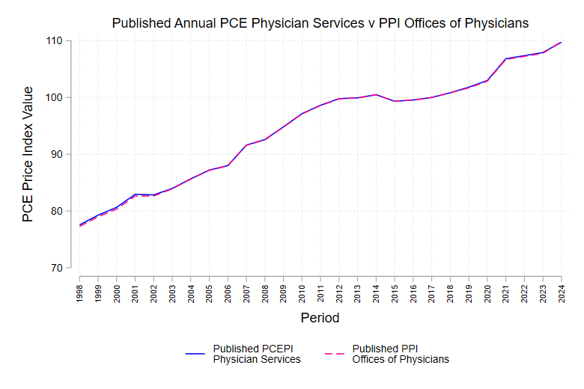

APPENDIX

Haver Codes
The following tables detail the codes, databases, and levels for each of the relevant series necessary for constructing the PCE Price Index. The convention for searching in Haver DLX is [code]@[database]. The series will automatically pull up. If the same code is linked in multiple datasets, when the code is searched, all locations will be listed. The given code will automatically open the dataset with the lowest frequency as allowed by the code you have inputted. For example, the quarterly level of a PCE component will open in a dataset with quarterly values and annual values, but rarely monthly values. When following the code for the monthly values, you may find the same quarterly code within that dataset as well.
When importing multiple series’ data from Haver, the data will automatically be pulled at the lowest frequency across series. For example, if you have one series at the monthly level and another at the quarterly level. Both series will automatically pull in at the quarterly level.
The USECON database has general information for all three price indices, but each has its own database that contains more detailed information on the specific price index. The respective databases are detailed below. A few details to keep in mind:
Personal Consumption Expenditures (PCE): [@USNA]
- The values will be under the “Personal Income and Outlays (T2)” header.
Producer Price Index (PPI): [@PPIR]
- The @PPIR database is preferred to the @PPI database as the @PPIR database is industry-based just as healthcare values are in the PPI. Both sub headers within @PPIR have relevant values, but for less aggregated values follow the “…Selected Industries and their Products” header then click “Health Care and Social Assistance (62)”.
- Quarterly and annual estimates are available if all the months needed are available. The estimates will be the average of the respective months.
Consumer Price Index (CPI): [@CPIDATA]
- The relevant national values can be found under “All Urban Consumer (CPI-U)” >> “United States City Average”.
- Quarterly and annual estimates are available if all the months needed are available. The estimates will be the average of the respective months.
Medicare Economic Index (MEI): [@GOVFIN]
- Base year is 2017. Physician earnings account for 52% and practice expenses account for 48% of index.
- All estimates available are the quarterly index values. Annual estimates are the average of all four respective quarterly index values.

Personal Consumption Expenditures (PCE)
Value | Level | Notation
Nominal Consumption  (Billions of Dollars) | Quarterly, SAAR | [base]
 | Annual | [base]A
Nominal Consumption  (Millions of Dollars) | Monthly, SAAR | [base]M
 | Quarterly, SAAR | [base]X
 | Annual | [base]Y
PCE Price Index | Monthly, SAAR | J[base]M
 | Quarterly, SAAR | J[base]
 | Annual | JA[base]
*SAAR = Seasonally Adjusted at Annual Rate

Personal Consumption Expenditures Codes (@USNA) |  |  | Nom Con  (Billions) |  | Nom Con  (Millions) |  |  | PCE  Price Index
 | Component | Base Code | Q | A | M | Q | A | M | Q | A
 | Health Goods and Services | CMED |  | X | X | X | X | X | X | X
Goods | Medical products, appliances, and equipment | CMEDP |  | X |  |  | X |  |  | X
 | Pharmaceutical and other medical products | CNOD | X | X | X | X | X | X | X | X
 | Pharmaceutical products | CNODR |  | X | X | X | X | X | X | X
 | Other medical products | CNODO |  | X | X | X | X | X | X | X
 | Therapeutic appliances and equipment | CDOO | X | X | X | X | X | X | X | X
Services | Health Care Services | CSD | X | X | X | X | X | X | X | X
 | Outpatient Services | CSDO | X | X | X | X | X | X | X | X
 | Physician Services | CSMP | X | X | X | X | X | X | X | X
 | Dental Services | CSMD | X | X | X | X | X | X | X | X
 | Paramedical Services | CSMO | X | X | X | X | X | X | X | X
 | Home health care | CSMOA |  | X | X | X | X | X | X | X
 | Medical laboratories | CSMOL |  | X | X | X | X | X | X | X
 | Other professional medical services | CSMOO |  | X | X | X | X | X | X | X
 | Hospital and nursing home services | CSMN | X | X | X | X | X | X | X | X
 | Hospitals | CSMHP | X | X | X | X | X | X | X | X
 | Nursing homes | CSMHN | X | X | X | X | X | X | X | X

Producer Price Index (PPI) Adjustment Indexes
Producer Price Index (@PPIR)
Component | Base Code
Selected Health Care Industries (Healthcare Services by Industry) | RHC
Offices of Physicians | R6211
Home Health Care Services | R6216
Medical and Diagnostic Laboratories | R6215
Medical Laboratories | R621511
Diagnostic Imaging Centers | R621512
Hospitals | R622
Nursing Care Facilities | R6231
*Not Seasonally Adjusted

Consumer Price Index (CPI) Adjustment Indexes
Adjustment | Level | Notation
Seasonally Adjusted | Monthly | [base]
Not Seasonally Adjusted | Monthly | [base]N

Consumer Price Index (@CPIDATA)
Component | Base Code | SA | NSA
Medical Care Services | UMS | X | X
Dental Services | UMSPT | X | X
Services by Other Medical Professionals | UMSPS | X | X

Medicare Economic Index (MEI) Indexes
 | Medicare Economic Index (@GOVFIN)
 | Component | Base Code
 | Total MEI | MEI
Physician  Earnings | Physician Compensation | MEIPC
 | Wages & Salaries | MEIWS
 | Benefits | MEIB
Practice  Expenses | Practice Expenses | MEIPE
 | Non-physician compensation | MEINC
 | Professional and technical wages | MEIPW
 | Managers wages | MEIMW
 | Clerical wages | MEICW
 | Services wages | MEISW
 | Non-physician benefits | MEIEB
 | Other practice expenses | MEIOP
 | Office expenses | MEIOE
 | Professional liability insurance | MEIPL
 | Medical equipment | MEIME
 | Drugs and supplies | MEIDS
 | Medical materials and supplies | MEIMS
 | Other professional expenses | MEIOX
 | Other professional expenses | MEIAO

Organization of Healthcare in the PCE and Published Nominal Expenditure Tables
The following are the PCE tables that publish the total expenditure in any period in terms of that period’s prices. To access these tables, follow the same procedure detailed in SECTION 1.
2.3.5: Personal Consumption Expenditure by Major Type of Product (A) (Q)
2.3.5U: Personal Consumption Expenditures by Major Type of Product and by Major Function (A) (Q) (M)
2.4.5: Personal Consumption Expenditures by Type of Product (A) (Q)
2.4.5U: Personal Consumption Expenditures by Type of Product (A) (Q) (M)
2.5.5: Personal Consumption Expenditures by Function (A)
2.8.5: Personal Consumption Expenditures by Major Type of Product, Monthly (M)
Following are the healthcare categorization systems the BEA employs, as mentioned in SECTION 1. The aggregated categories for goods and services, within their respective systems, are in blue. The components in gray can only be found in the PCE’s Underlying Detail Tables. In brackets, following each category or component, is a list of PCE tables where corresponding total expenditure values in terms of a period’s quantities and prices can be found.
KEY
italicized | Healthcare service relevant to this guide
(U) | Main table and underlying table
U | Underlying table only

(1) General Categorization of Healthcare Goods and Services

- Goods [2.3.5(U), 2.4.5(U), 2.8.5]
  - Durable goods [2.3.5(U), 2.4.5(U), 2.8.5]
    - Other durable goods [2.3.5(U), 2.4.5(U), 2.8.5]
      - Therapeutic appliances and equipment [2.4.5(U), 2.5.5]
        - Therapeutic medical equipment [2.4.5U]
        - Corrective eyeglasses and contact lenses [2.4.5U]
  - Nondurable goods [2.3.5(U), 2.4.5(U), 2.8.5]
    - Other nondurable goods [2.3.5(U), 2.4.5(U), 2.8.5]
      - Pharmaceutical and other medical products [2.4.5(U), 2.5.5]
        - Pharmaceutical products [2.4.5U, 2.5.5]
          - Prescription drugs [2.4.5U]
          - Nonprescription drugs [2.4.5U]
        - Other medical projects [2.4.5U, 2.5.5]
- Services [2.3.5(U), 2.4.5(U), 2.8.5]
  - Health care [2.3.5(U), 2.4.5(U), 2.8.5]
    - Outpatient Services [2.4.5(U), 2.5.5]
      - Physician services [2.4.5(U), 2.5.5]
      - Dental services [2.4.5(U), 2.5.5]
      - Paramedical services [2.4.5(U), 2.5.5]
        - Home health care [2.4.5U, 2.5.5]
        - Medical laboratories [2.4.5U, 2.5.5]
        - Other professional medical services [2.4.5U, 2.5.5]
          - Specialty outpatient care facilities and health and allied services [2.4.5U]
          - All other professional medical services [2.4.5U]
    - Hospital and nursing home services [2.4.5(U), 2.5.5]
      - Hospitals [2.4.5(U), 2.5.5]
        - Nonprofit hospitals’ services to households [2.4.5U]
        - Proprietary hospitals [2.4.5U]
        - Government hospitals [2.4.5U]
      - Nursing homes [2.4.5(U), 2.5.5]
        - Nonprofit nursing homes’ services to households [2.4.5U]
        - Proprietary and government nursing homes [2.4.5U]
  - Financial services and insurance [2.3.5(U), 2.4.5(U), 2.5.5, 2.8.5]
    - Insurance [2.4.5(U), 2.5.5]
      - Net health insurance [2.4.5(U), 2.5.5]
        - Medical care and hospitalization [2.4.5U, 2.5.5]
        - Income loss [2.4.5U, 2.5.5]
        - Workers’ compensation [2.4.5U, 2.5.5]
(2) Categorization of Aggregated Healthcare Goods and Services
- Health [2.3.5U, 2.5.5]
  - Medical products, appliances, and equipment [2.5.5]
    - Pharmaceutical and other medical products [2.4.5(U), 2.5.5]
      - Pharmaceutical products [2.4.5U, 2.5.5]
      - Other medical products [2.4.5U, 2.5.5]
    - Therapeutic appliances and equipment [2.5.5]
  - Outpatient services [2.4.5U, 2.5.5]
    - Physician services [2.4.5(U), 2.5.5]
    - Dental services [2.4.5(U), 2.5.5]
    - Paramedical services [2.4.5(U), 2.5.5]
      - Home health care [2.4.5U, 2.5.5]
      - Medical laboratories [2.4.5U, 2.5.5]
      - Other professional medical services [2.4.5U, 2.5.5]
  - Hospital and nursing home services [2.4.5(U), 2.5.5]
    - Hospitals [2.4.5(U), 2.5.5]
    - Nursing homes [2.4.5(U), 2.5.5]

Keep mentioning that Kelli has a Fed Letter idea where it is a decomposition exercise to explain why healthcare inflation is always greater than overall inflation. This can come naturally from trying to figure out the aggregation to levels without their own deflator indices.

Essentially- PCE healthcare service inflation can be decomposed as ~ \Sum(across each subcategory)[change in prices * weights ]. Q: is this true for CPI?
-in PCE: weights are expenditures shares, i.e., total spending on subcategory/ total spending on healthcare. Q: what is this in CPI?

-in PCE: change in prices are change in PPI. Q: what is this in CPI?

Decomp graphs
            - Overall inflation
              - PPI, delta ppi, weights

            - Healthcare service inflation
              - Component PPI, delta ppi, weights

Corresponding table numbers for PCE nominal expenditures are in the Appendix.
Refer to Appendix.
Refer to Consideration 2.
The base year is updated during each comprehensive update. Please refer to NIPA handbook for more details.
Specific time periods for which the specified data are used for are detailed in the NIPA Handbook Chapter 5. Some additional information provided in the Consideration 1 Example.
Refer to Table 5 for information on which payers are included in PPI and CPI.
Official page on “Health Care Services in the Producer Price Index.”
Official page on “Measuring Price in the CPI: Medical Care.”

